**AWS Task-2**

**Task Description:**

Set up a VPC with an Internet gateway, create a public subnet with 256 IP addresses, a private subnet with 256 IP addresses, make a route table connecting the Internet gateway and the subnets, and launch a Linux EC2 instance by using the above VPC and public subnet.

Explanation:

1. Login to AWS console, navigate to VPC service

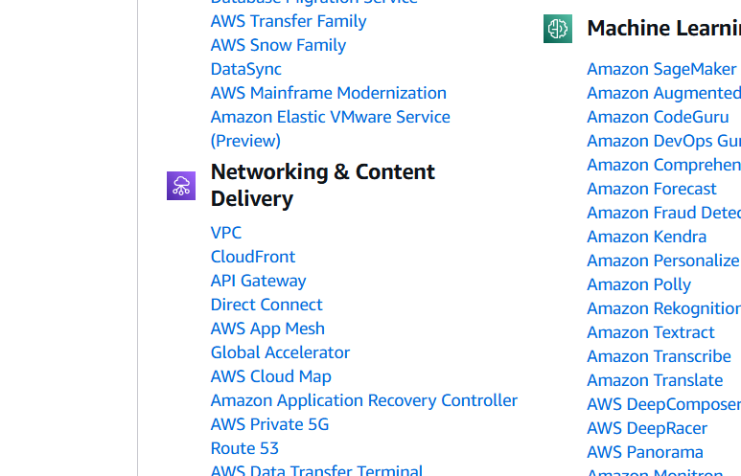

1. In VPC dashboard, Click create VPC.

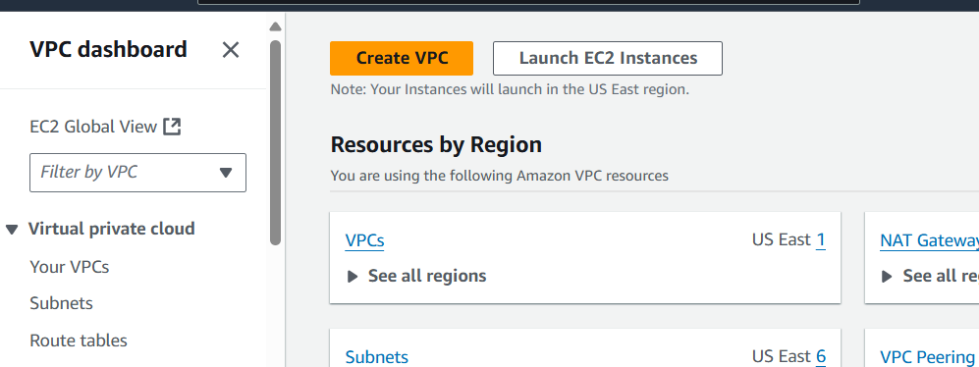

In Create VPC, set a name tag – myvpc >> IPv4 CIDR block: 10.0.0.0/16 >> Enable DNS resolution and DNS hostnames>> then create VPC.

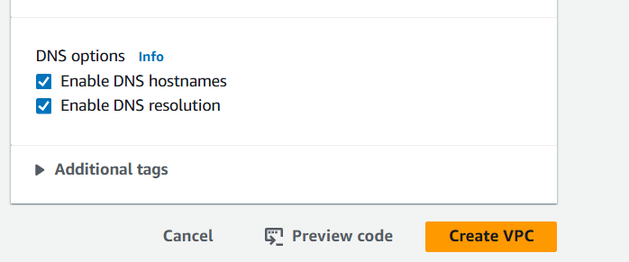

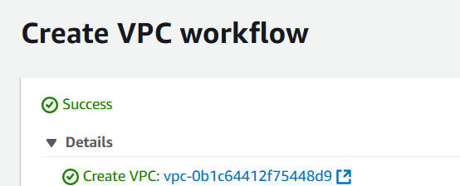

1. Click create internet gateway

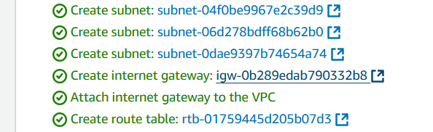

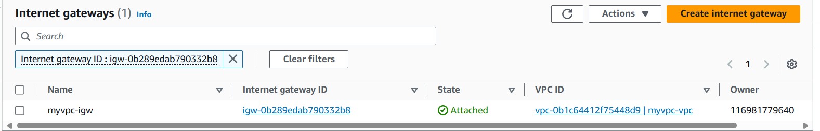

Set a nametag and click create.

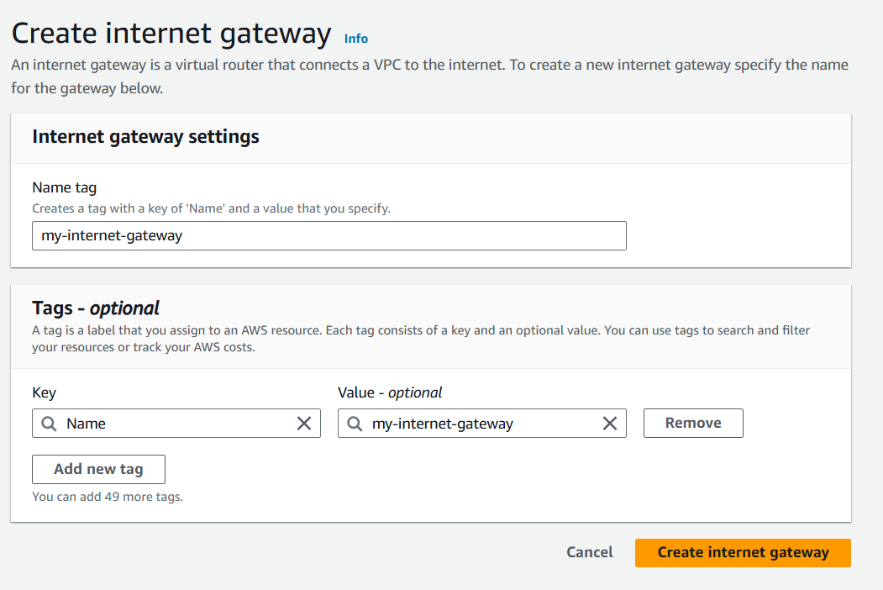

1. To connect internet gateway to VPC, In my-internet-gate way Navigate actions > Attach to VPC >select myvpc (also vpc id can be used)

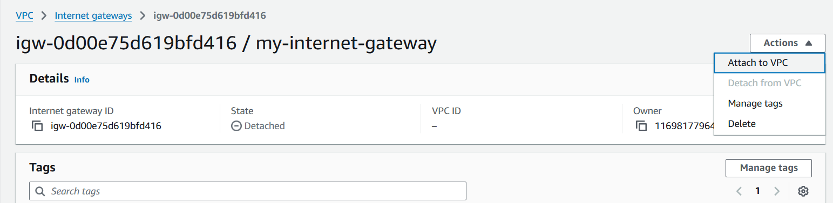

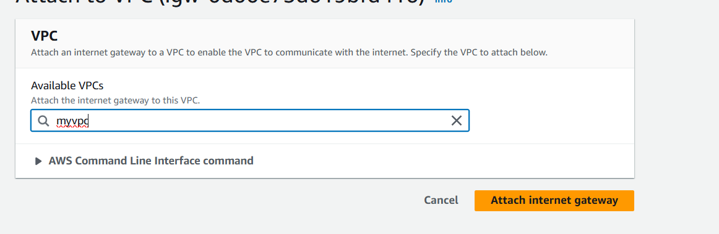

Click attach internet gateway.



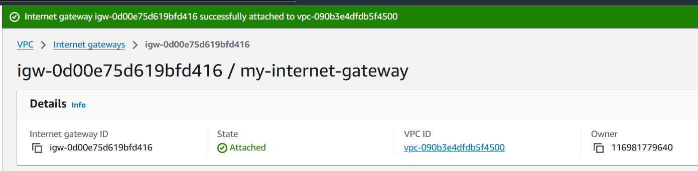

1. Navigate to subnet section and click create subnet.

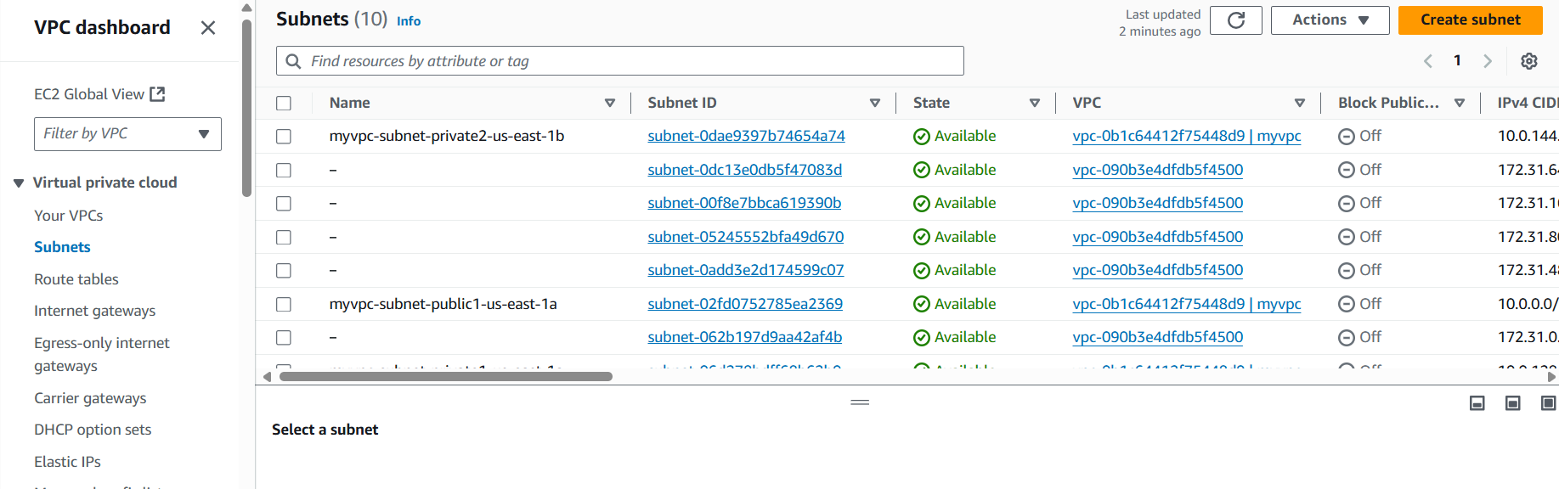

Choose my vpc

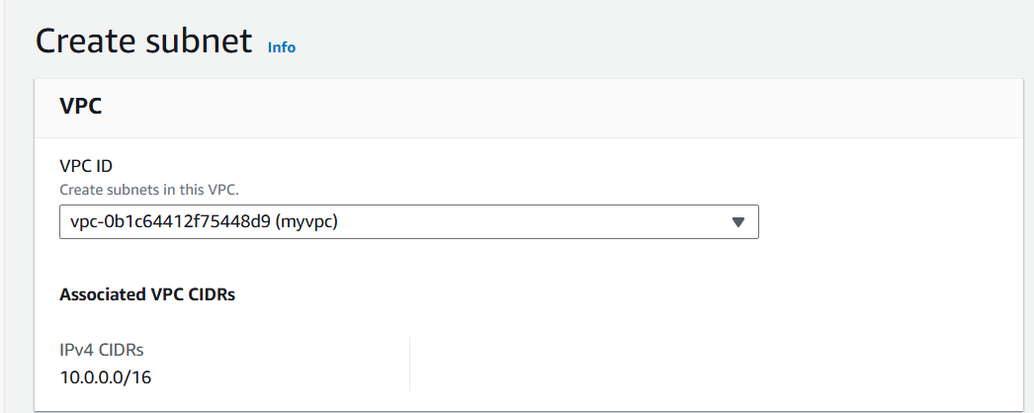

Name tag – my -subnet

Availabilty zone – US East

IIPv4 subnet CIDR block: 10.0.32.0/24 (since 256 IPs)

Click create subnet

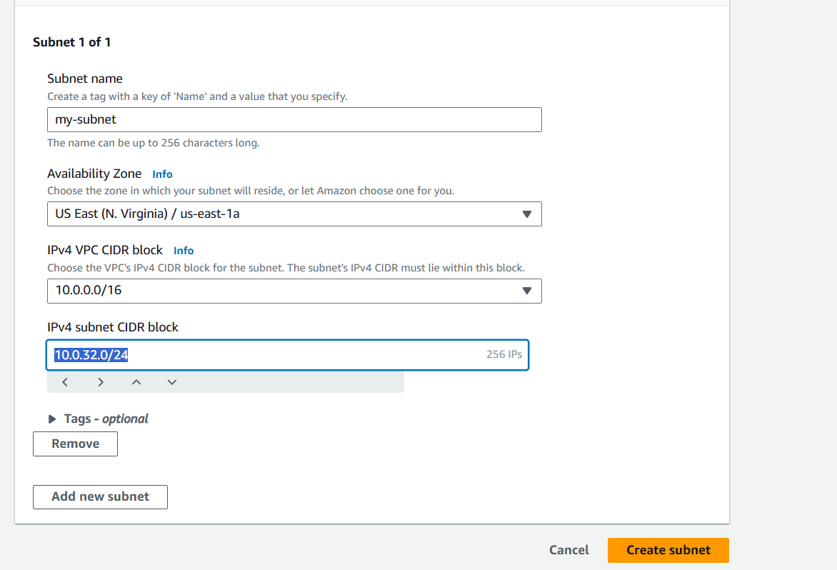

1. To enable public Ips auto assignment, navigate

Actions > Edit subnet settings > ckick Enable auto-assign public IPv4 address > save

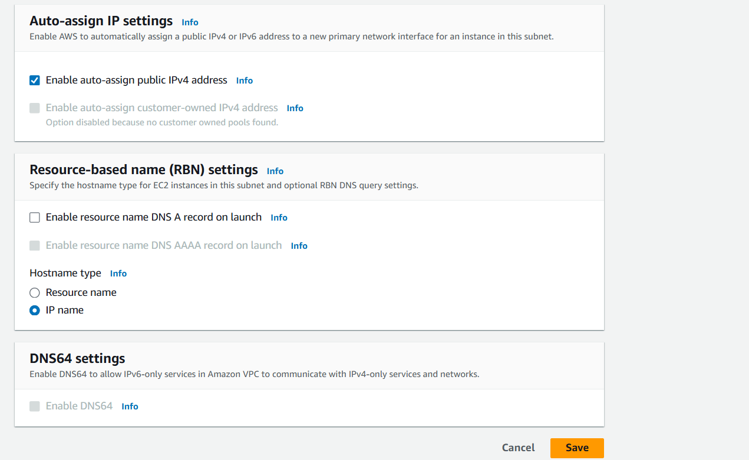

1. To Create private subnet, go to subnets, create subnet, choose my vpc.

Name tag - my-subnet-private

IPv4 subnet CIDR block - 10.0.33.0/24

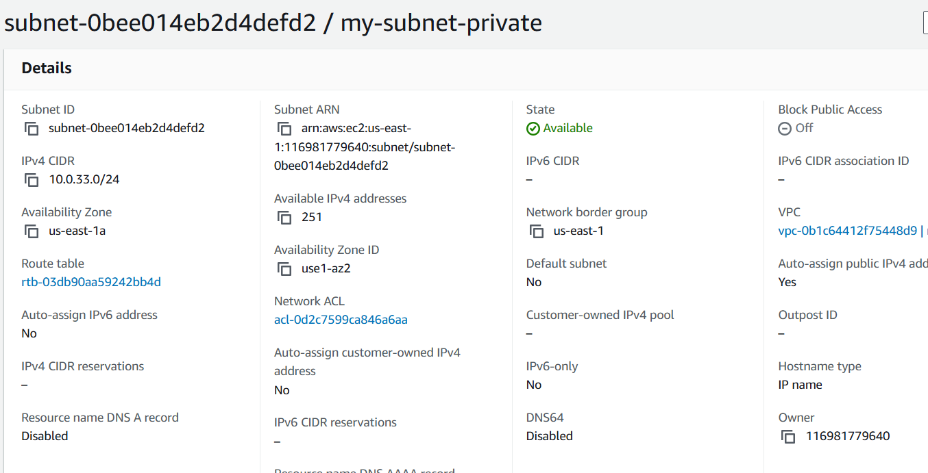

1. To create Route table, go to route cable section and create Route table

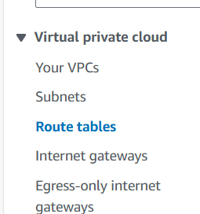

Set the following details.

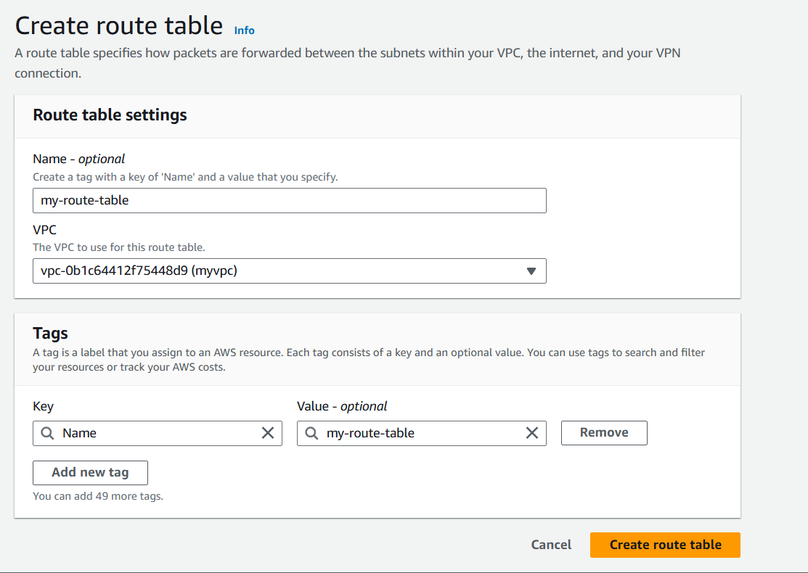

Post creation of route table, navigate to Actions > edit subnet associations

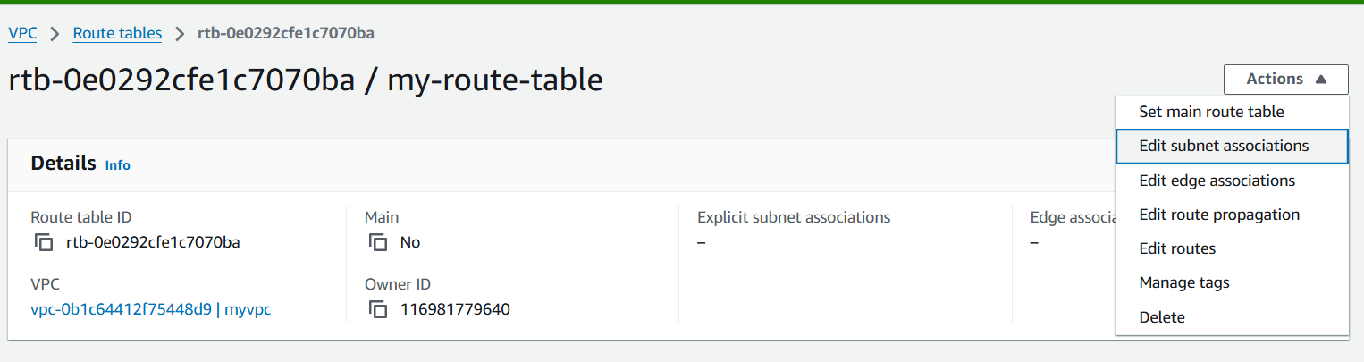

Select mysubnet and save.

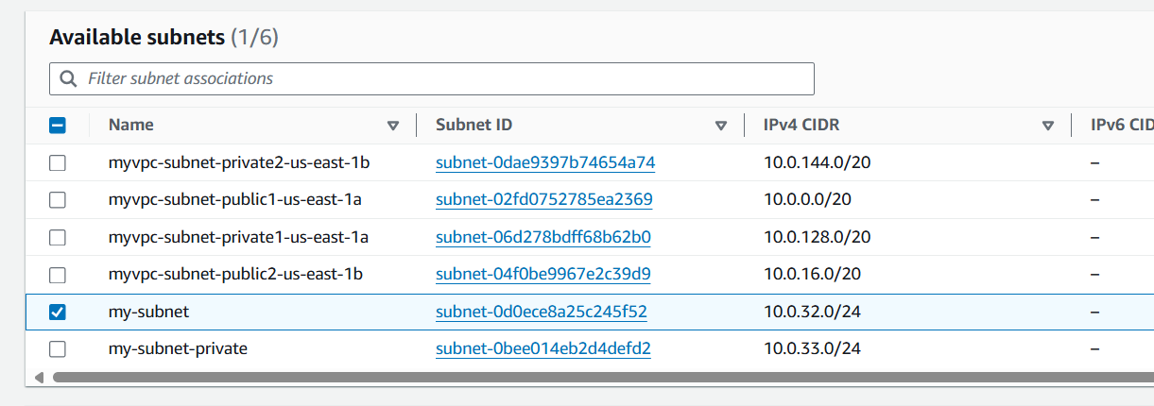

1. To add a route to internet gateway, select my-route-table>Actions>edit routes

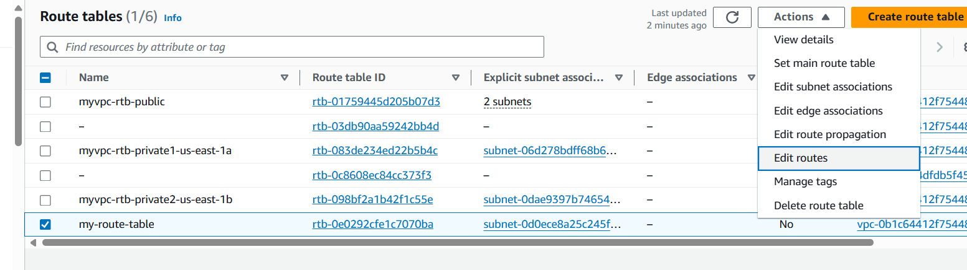

Add the following route and save.

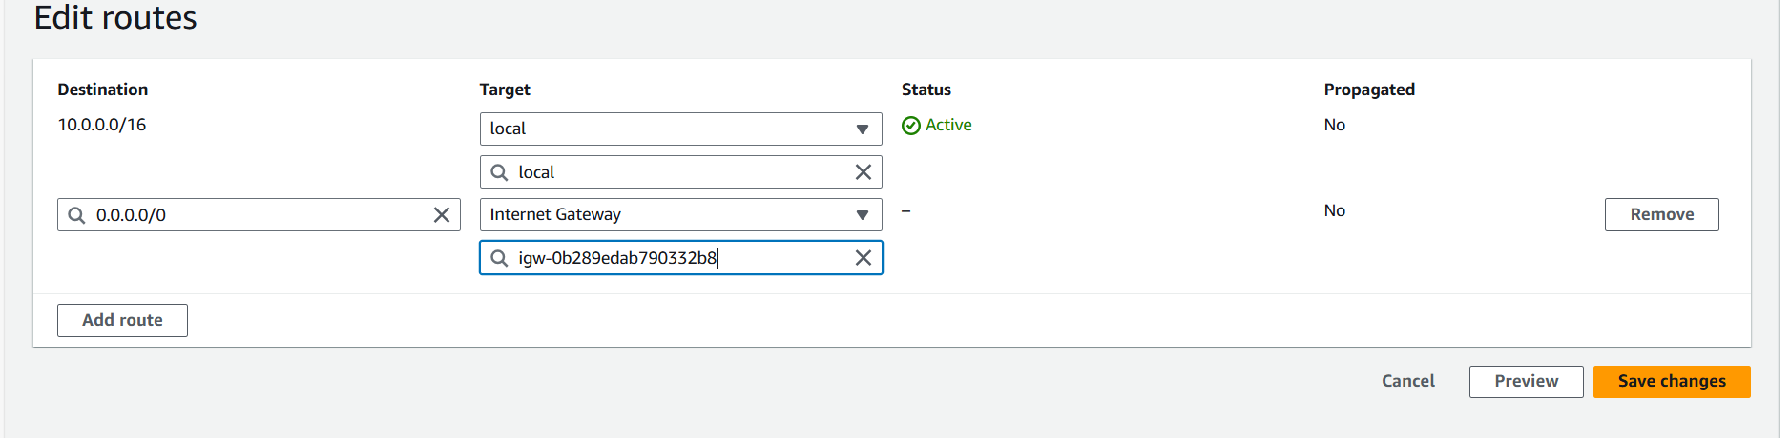

1. launch a Linux EC2 instance by navigating,

Ec2 dashboard > Launch Instance

Name - Linux_Instance

AMI – Amazon Linux

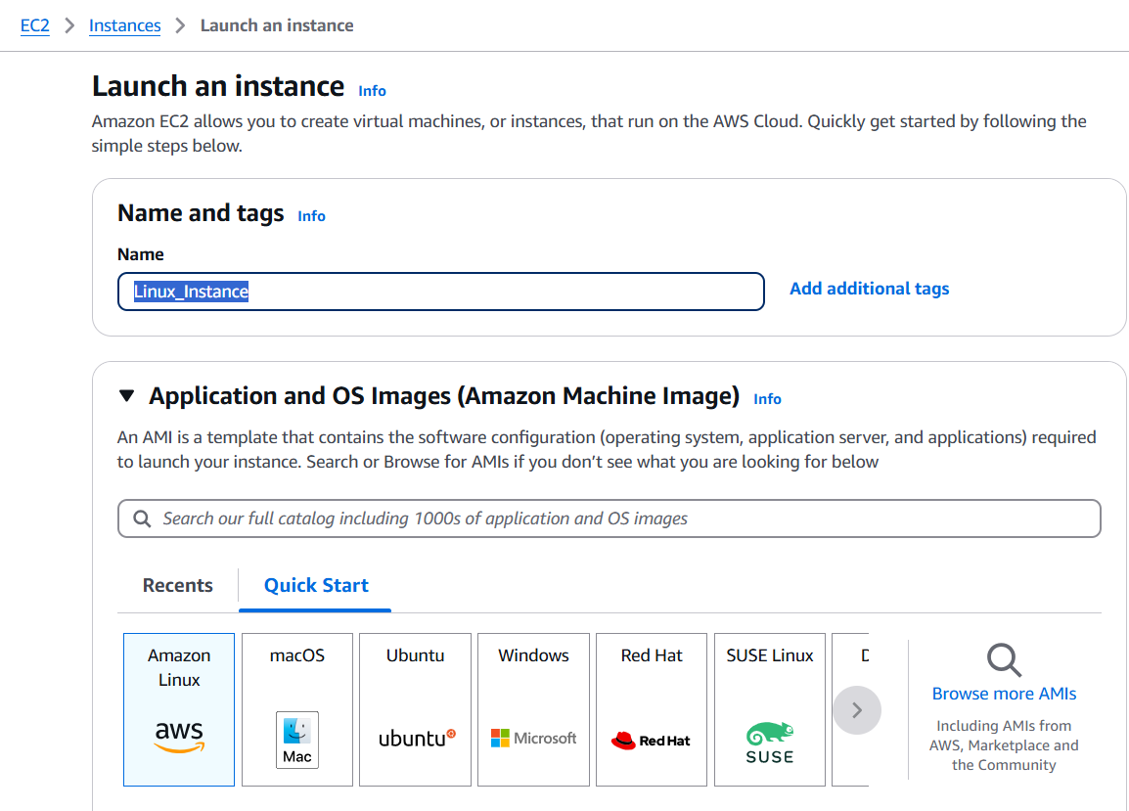

Instance type – t2.micro

Create (Linux) or use a existing key pair

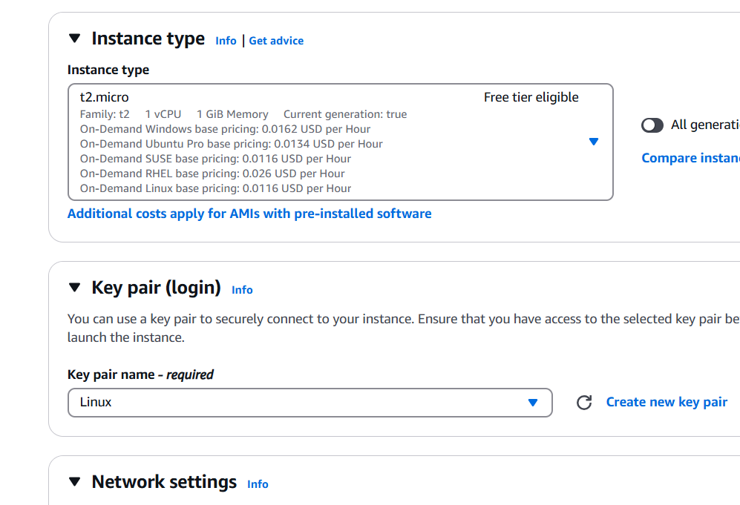

Choose the network settings as below

VPC – myvpc

Subnet – my-subnet

Enable auto assign public IP

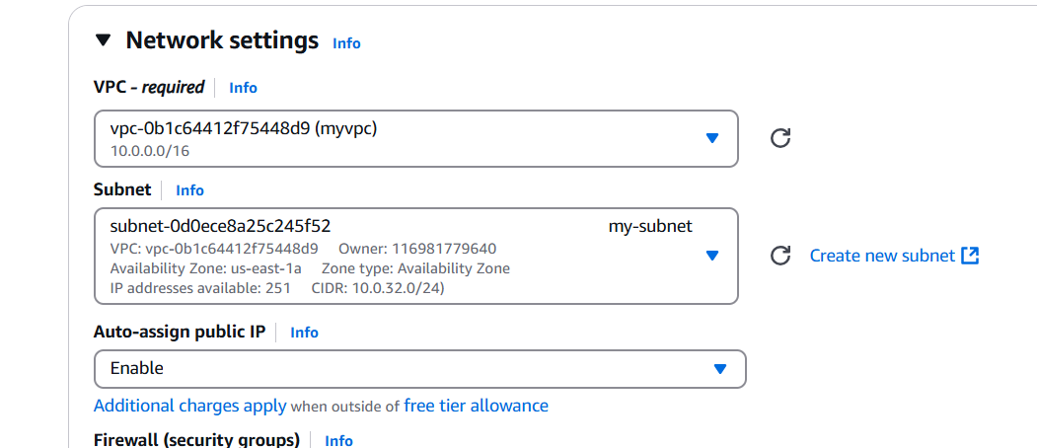

Security group

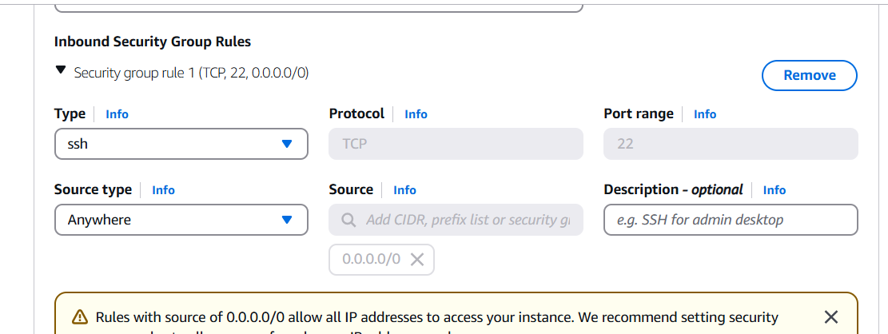

Click Launch Instance.

1. To verify, Connect to the instance

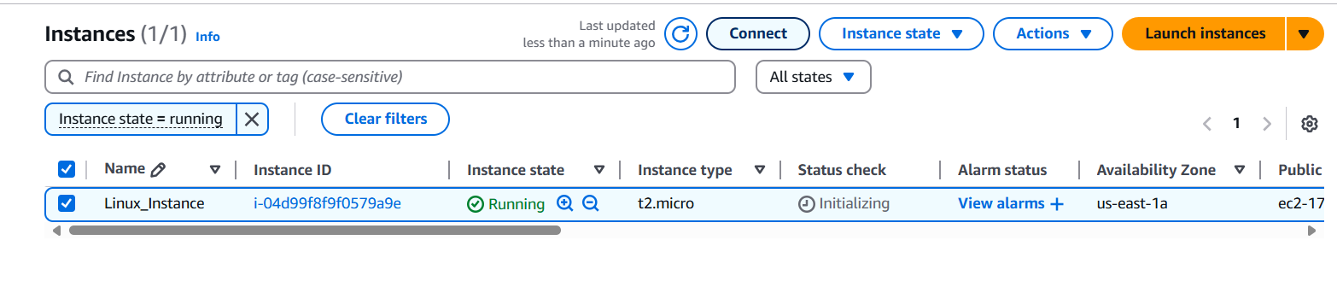

Follow the steps

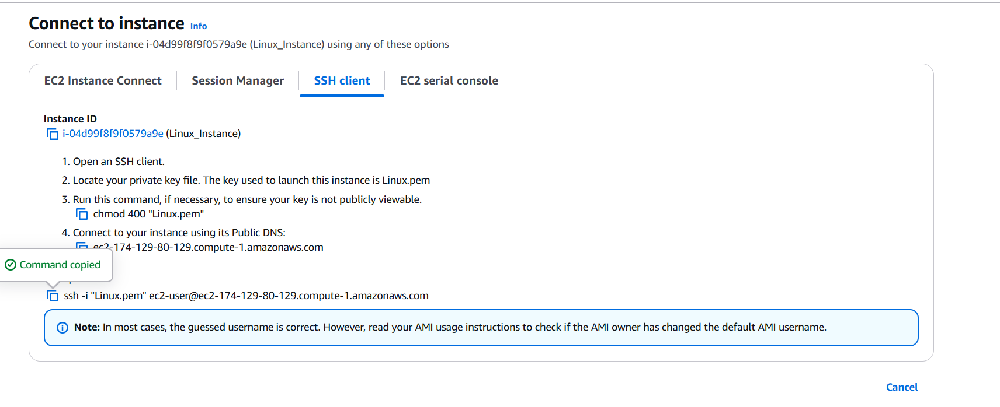

Output :

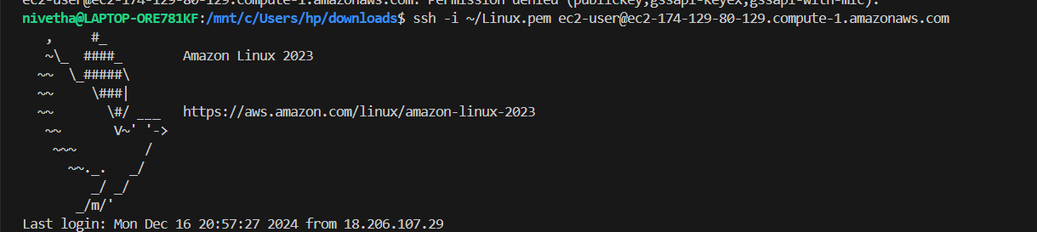

EC2 Instance is Running, SSH Connection is Established, VPC is created, subnet setup is done and internet gateway is added and launched EC2 instance.